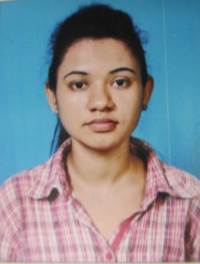**BANDITA BISWAS**

Ph. +91-9038717376

Chandannagar, Hooghly

bandita.biswas@bt.com

**CAREER OBJECTIVE**

Play a responsible role in an organization that enhances my skills and capabilities, challenges me to perform exceptionally, preferably in a progressive and competitive work culture in a technology driven company.

***PROFESSIONAL* STRENGHTS**

* Core strength is working in a team based environment, through hands on approach.
* Excellent communication skills.
* Good problem-solving skills in crucial situations.
* Adaptive to any atmosphere.

**TECHNICAL SKILLS**

* **Software:** MS Office Packages including MS-Word, Excel, PowerPoint etc.
* **Operating Systems:** Microsoft Windows 98/XP/Vista/7/8.

**PROFESSIONAL EXPERIENCE**

**WIPRO (*August 2013- February 2015)***

**TECHNICAL SUPPORT EXECUTIVE (August 2013-February 2015)**

* Handling broadband technical issues of the British Telecom (UK) customers.
* Giving remote desktop support to the customers over the phone.
* Configure and troubleshoot email client and other broadband and desktop related issues of British Telecom customers.

British telecommunications plc (February 2015 – Present)

* Managing and fixing the orders of British Telecom customers.

**EDUCATIONAL QUALIFICATIONS**

* BBA(H) from Bengal School Of Technology & Management under West Bengal University Of Technology in 2013 (Secured 7.66).
* Class 12th (Commerce) from Chandannagar Banga Vidyalaya, Chandannagar (WBCHSE) in 2010 (Secured 63%).
* Class 10th from St.Anthony's High School, Chandannagar(WBBSE) in 2008 (Secured 62.5%).

**LANGUAGES KNOWN**

English (UK), Hindi, Bengali.

**PERSONAL DETAILS**

**Name:** Bandita Biswas.

**Date of Birth:** 11th September 1992.

**Father’s name:** Mr. Dhananjay Biswas.

**Sex:** Female.

**Marital Status:** Single.

**Nationality:** Indian.

**Hobbies:** Listening Music, Watching Movies, Playing badminton, Reading Books.

**Current Address:** 26/Gurusaday Dutta Road,

Chandannagar,

Hoogly,

West Bengal,

Pin 712136.

DECLARATION

I hereby declare that all the details given above are true to the best of my knowledge and belief

Place:-

Date: - **BANDITA BISWAS**